1. **Gather existing information (data, reports…)**

*[WHO will type in an email template + send emails – introduce WHO as a team]*

Who do we need to contact?

* Literacy trainer [name]
* ALSO [name]
* Executive principal [name]
* Teacher [name]
* DPC [name]

1. **Lines of enquiry (Questions) – information we would like to gather**
   1. What **helps** young people (to engage) in learning? **Why**?
   2. What **hinders/gets on the way/barriers** young people (to engage) in learning? **Why**?
   3. What are some of the **ideas** that they believe could increase young people (engagement) in learning?
2. **Define tools/methods to explore questions**
3. Podium – 3 key things that help
4. Circles of support & Day in a life / week – what helps/hinders?
5. Lego – ideas to increase young people’s engagement in learning?

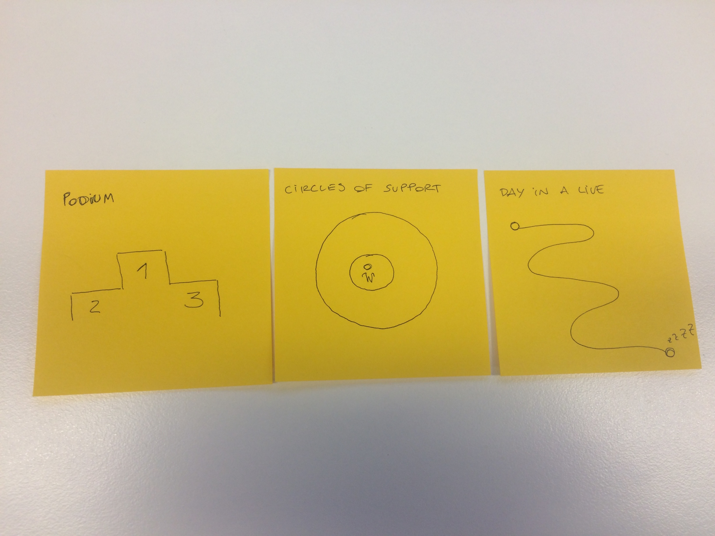

*[WHO to prepare the tools and a detailed guide for this conversations]*

1. **List of people that we will meet**

**Students** (6 to 8) *– having lunch with them while they are at school and buying their favourite lunch – Aboriginal and non-Aboriginal*

* 2 engaged (positive deviance, high achievers) – *ask teachers in the school [WHO will ask WHO?] (Head learning support)]*
* 4-6 disengaged - *boys group program – 14yo, 15yo, 16yo, 17yo [WHO will speak to WHO?]*

**Family** (6 to 8) – *students’ family members, we will recruit them through young people*

**Teachers** (4) – if possible teachers that are in the classroom with some of those students *[WHO will speak to WHO?]*

**Principal** (1) + **Deputy Principals** (2) - *[WHO will speak to WHO?]*

**Support staff in the school** (3) - *[WHO will speak to WHO?]*

* Psychologists – school counselor
* Career advisor
* Peter – Aboriginal Learning Support Officer (ALSO)

**Education department** (2) – *[Name]*

* Deputy Principal – *[Name]*
* Principal - *[Name]*

**Other education programs and services** (8) *[WHO will do this?]*

* List programs and contacts…

**People in the community** *– [WHO will do this?]*

* List organisations/roles and contacts

**Others services** *– [WHO will do this?]*

* List services and contacts

1. **Ethics framework – consent form**

Sections in the consent form (please see TACSI’s example as an inspiration):

* About the working group
* About this project
* What does taking part in this project mean?
* How will my information be used?
* A few last things to keep in mind…

*[WHO will prepare the text in a word document?]*

1. **Vouchers / thank you’s**

Define what would be per cohort:

* Students - *vouchers*
* Families - *vouchers*
* Teachers, principal, support staff - *chocolates*
* Education department - *chocolates*
* Other education programs and services - *chocolates*
* People in the community - *chocolates*
* Others services - *chocolates*